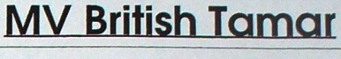
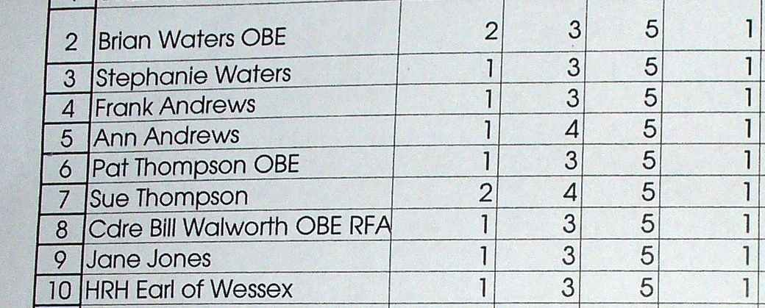



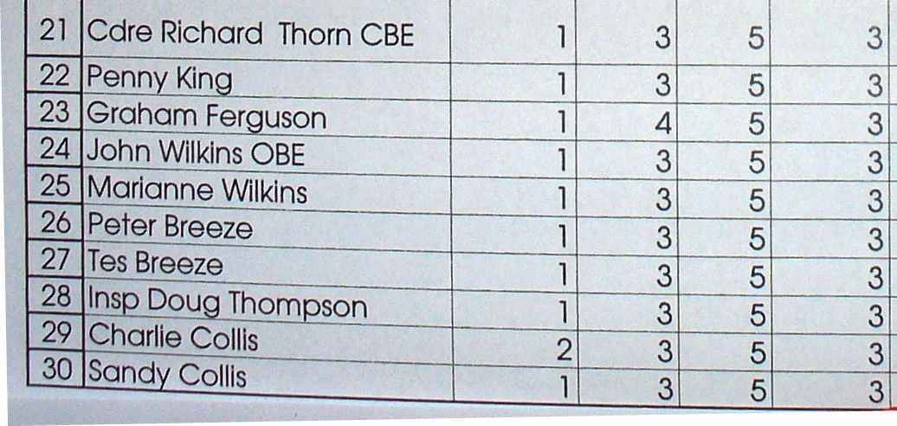

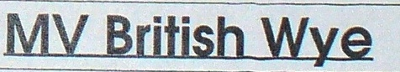

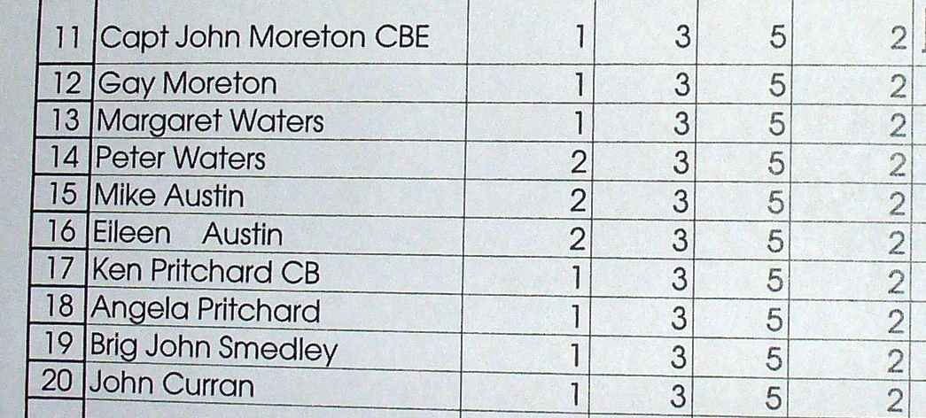


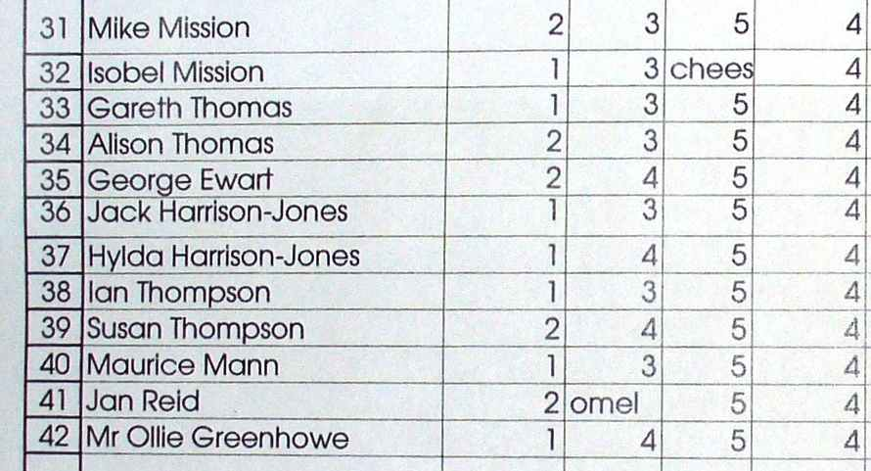

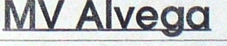

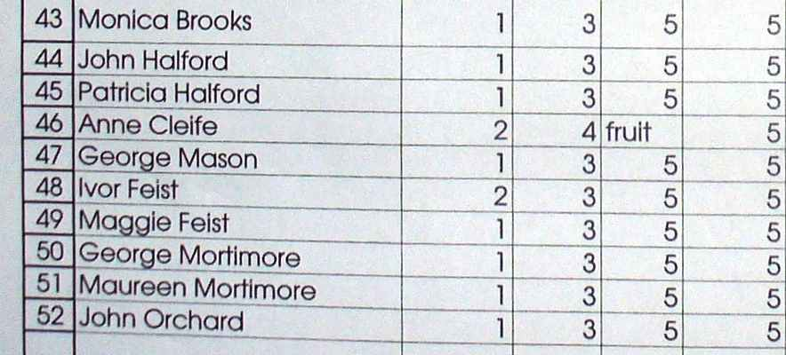

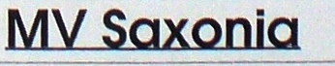
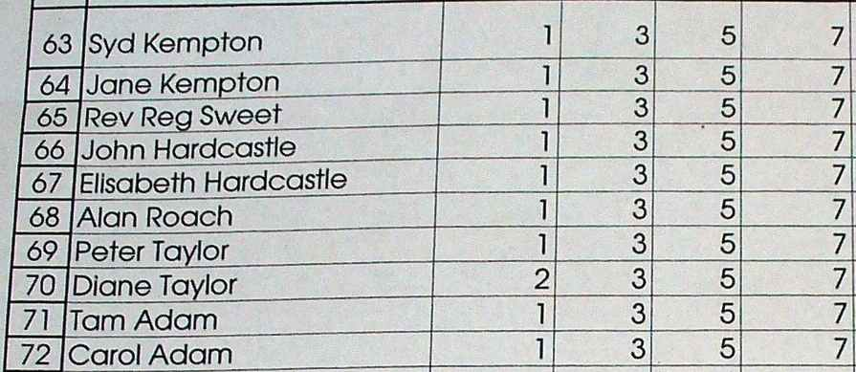

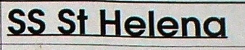

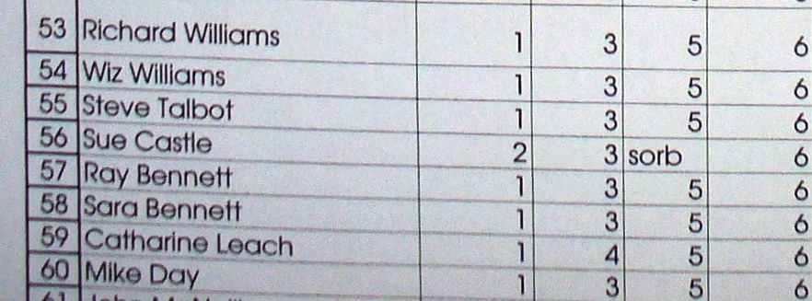

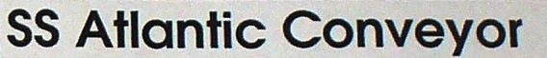

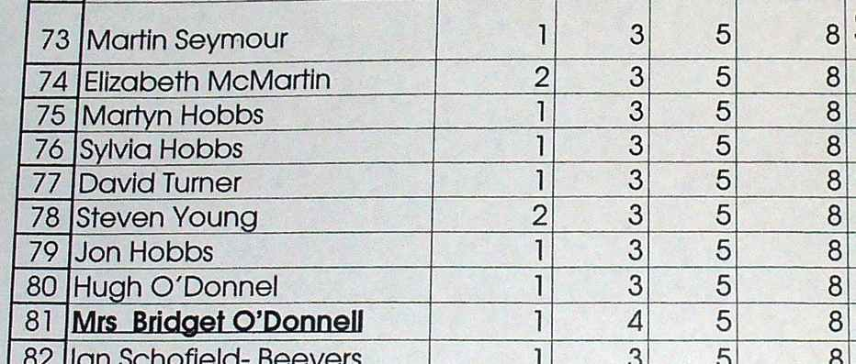

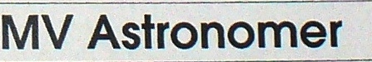

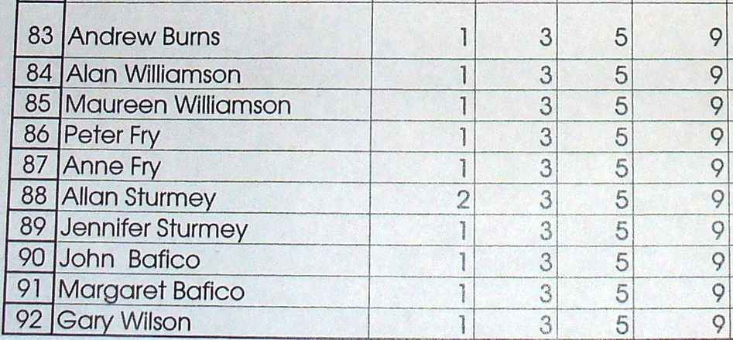

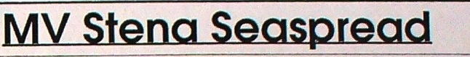

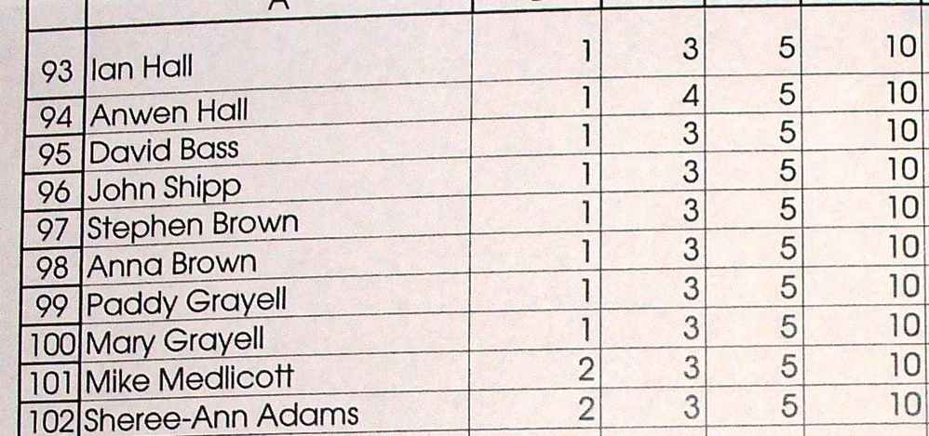

Menu
Starter

Trio of Salmon, Smoked, Gravadlax and Poached, Black Pepper, Creme Fresh, Lambs Lettuce and Rocket Salad
or
Salad of Olive, Herb Bocconcini, Sun Blushed Tomato and Artichoke, Basil Oil.
Main Course
Roast Saddle Lamb filled with Sun Blushed Tomato and Asparagus, Crushed Peas and a Mint Jus
or
Wild Mushroom, Leek and Parmesan Risotto, Red Pepper Coulis.

Dessert
Assiette of Desserts - Warm Chocolate Pot, Sorbet and Mousse.
Coffee and Petit Fours

Les vins: Rouge et Blanc De Vere
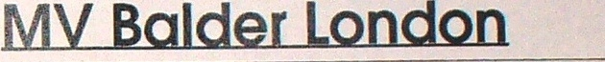

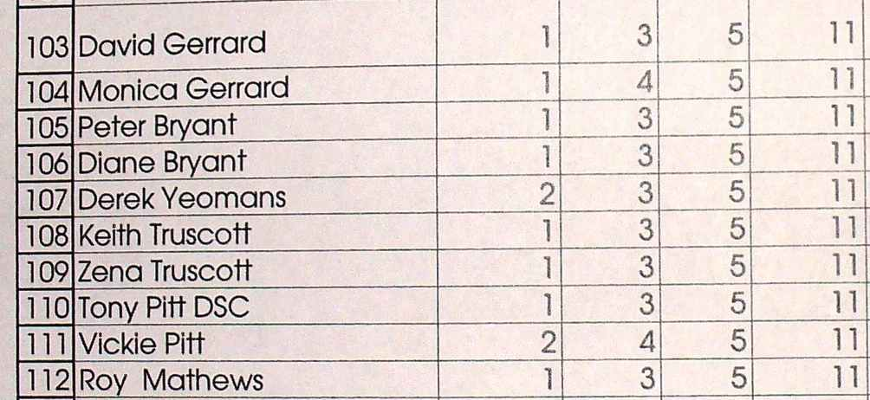

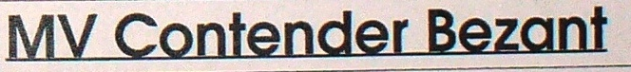
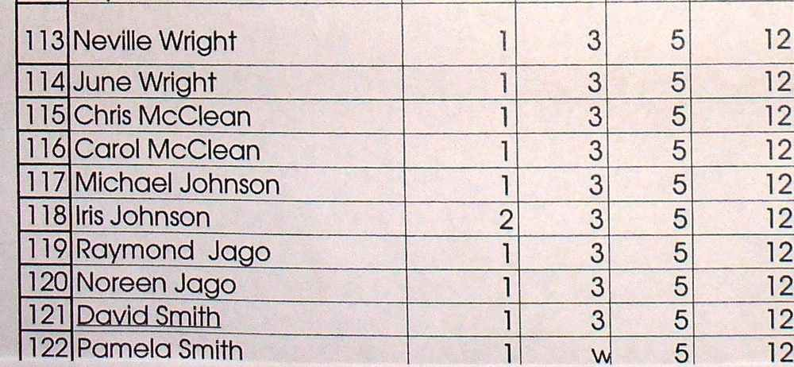

Programme
1845 Members and guests assemble in Mayflower Suite Bar.
Raffle Tickets on sale from Sea Cadets. Please buy some.
1930 Patron arrives, meets welcoming party in foyer. Proceeds to bar to meet members.
1950 Paddy Grayell (former CPO (RN)) Pipes to Dinner
2000 Welcome and thanks: Brian Waters QBE Solent Chairman: Grace: Rev Reg Sweet Solent Hon Chaplain.
2005 Romeo close up. Dinner is served.

2200 ish Call to order for the Grand Raffle Draw:
M.C. Alan Williamson, assisted by senior Sea Cadets.
0/C The Loyal Toast in the Diamond Jubilee Year:
Pat Thompson QBE immediate Past Chairman RFAA.
2100 Call to order for speeches: Pat Thompson OBE Commodore Bill Walworth OBE RFA
0/C End of formal dinner programme. Patron departs.
0/C Replenish glasses and pump bilges. Raffle tickets still on sale.

0/C Repair to the Bar...The Grand Raffle Draw: Prizes exceed £1200! If you hold a winning ticket please stay at your table and wave it around, your prize will be delivered to you by a Sea Cadet.





